Finding row sum of n*n matrix:
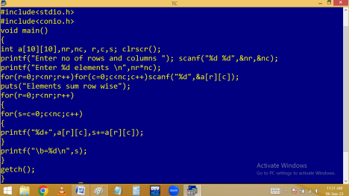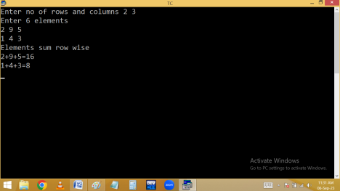
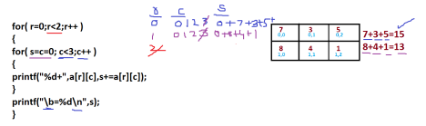Finding no of even, odd, zero elements in a matrix as follows.
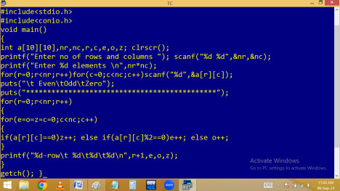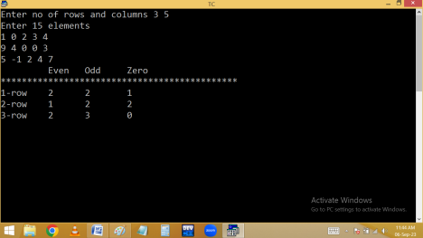
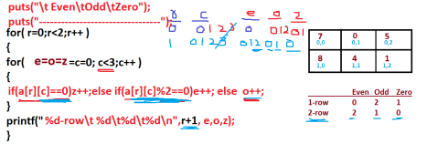Transpose of n*n matrix:
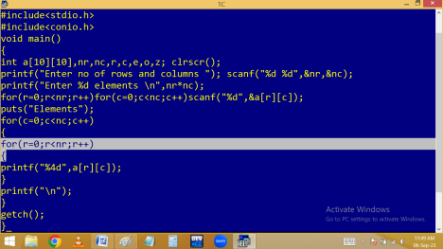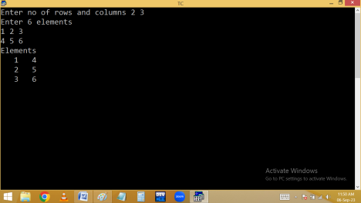
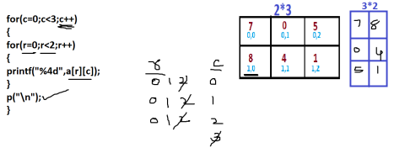Method 2:
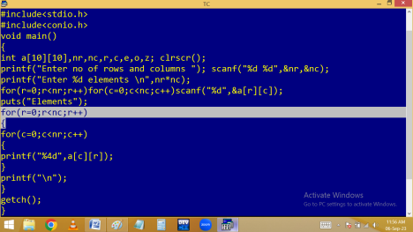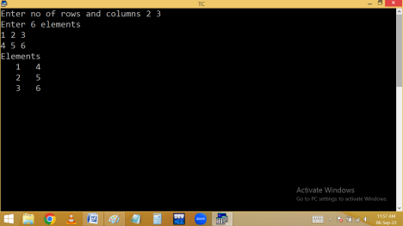
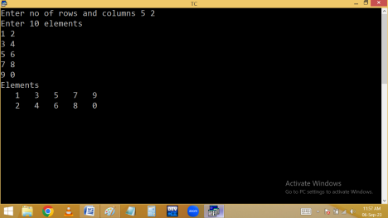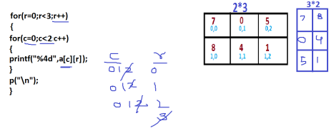Finding trace of n*n matrix:
Sum of principle diagonal elements is called trace.
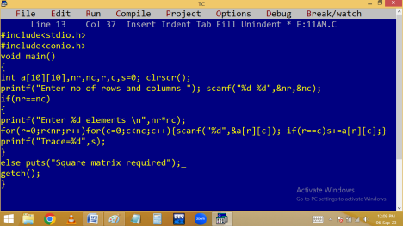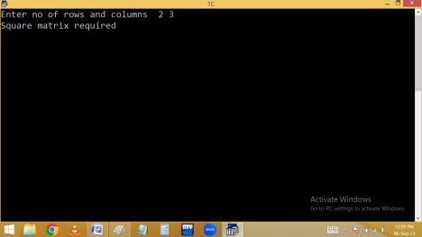
Eg. find the trace of right diagonal elements:
Arrange elements in ascending order:
#include<stdio.h>
#include<conio.h>
void main()
{
int a[10][10],nr,nc,r,c,i,j; clrscr();
printf("Enter no of rows and columns "); scanf("%d %d",&nr,&nc);
printf("Enter %d elements \n",nr*nc);
for(r=0;r<nr;r++)for(c=0;c<nc;c++)
scanf("%d",&a[r][c]);
for(r=0;r<nr;r++)
{
for(i=0;i<=nc-2;i++)
{
for(j=i+1; j<=nc-1;j++)
{if(a[r][i]>a[r][j]){int t=a[r][i];a[r][i]=a[r][j];a[r][j]=t;}}}} puts("Sorted elements");
for(r=0;r<nr;r++)
{
for(c=0;c<nc;c++)printf("%4d",a[r][c]);
printf("\n");
}
getch();
}
#include<stdio.h>
#include<conio.h>
void main()
{
int a[10][10],nr,nc,r,c,i,j; clrscr();
printf("Enter no of rows and columns "); scanf("%d %d",&nr,&nc);
printf("Enter %d elements \n",nr*nc);
for(r=0;r<nr;r++)for(c=0;c<nc;c++)
scanf("%d",&a[r][c]);
for(r=0;r<nr;r++)
{
for(i=0;i<=nc-2;i++)
{
for(j=i+1; j<=nc-1;j++)
{if(r%2==0){if(a[r][i]>a[r][j]){int t=a[r][i];a[r][i]=a[r][j];a[r][j]=t;}}
else {if(a[r][i]<a[r][j]){int
t=a[r][i];a[r][i]=a[r][j];a[r][j]=t;}} } } }
puts("Sorted elements");
for(r=0;r<nr;r++)
{
for(c=0;c<nc;c++)printf("%4d",a[r][c]); printf("\n");
}
getch();
}
Column wise sorting:
#include<stdio.h>
#include<conio.h>
void main()
{
int a[10][10],nr,nc,r,c,i,j; clrscr();
printf("Enter no of rows and columns "); scanf("%d %d",&nr,&nc);
printf("Enter %d elements \n",nr*nc);
for(r=0;r<nr;r++)for(c=0;c<nc;c++)
scanf("%d",&a[r][c]);
for(c=0;c<nc;c++)
{
for(r=0;r<nr;r++)
{
for(i=r+1; i<nr;i++)
{if(a[r][c]>a[i][c]){int t=a[r][c];a[r][c]=a[i][c];a[i][c]=t;}} } }
puts("Sorted elements");
for(r=0;r<nr;r++)
{
for(c=0;c<nc;c++)printf("%4d",a[r][c]);
printf("\n");
}
getch();
}
Arrange even row elements in ascending and odd row in descending order.

